🛡️ AWS Secrets Manager kya hai?
Secrets Manager ek AWS service hai jiska use sensitive info (jaise DB passwords, API keys, tokens) ko securely store aur manage karne ke liye hota hai.
👉 Iska main kaam hai:
- Secrets store karna
- Unko encrypt karna (using KMS)
- Time-to-time rotate karna (auto-password change)
- IAM ke through access control dena

🔑 Example Secrets:
Secret Type | Real-World Use
DB password | RDS database ke liye login credentials
API key | Third-party service (e.g., Stripe, Twilio) ke liye
Token | OAuth, JWT ya internal apps ke tokens

📚 Step-by-Step: AWS Secrets Manager Kaise Kaam Karta Hai
🔹 Step 1: Secret Create Karna
- Console me jao: Secrets Manager → Store a new secret
- Secret type choose karo (e.g. "RDS credentials")
- Username/password daalo ya koi key-value pair
- Optionally rotation enable karo (auto-update)
✅ Encryption by default hota hai using AWS KMS key.

🔹 Step 2: Secret Access Karna (Code se)
Aap secret ko fetch kar sakte ho:
Python Example:
python
CopyEdit
import boto3
import json

client = boto3.client('secretsmanager')
response = client.get_secret_value(SecretId='my-secret-name')
secret = json.loads(response['SecretString'])
print(secret['password'])

🔹 Step 3: Secret Rotate Karna
- Aap enable kar sakte ho auto-rotation (e.g., har 30 din me password change)
- AWS Lambda function se integration hota hai (jo naya password generate kare)
- Ye auto-update kar deta hai DB + Secrets Manager dono jagah

🔐 Security Points (Exam ke liye zaroori):
Feature | Detail
🔒 Encryption | KMS ke through har secret encrypted hota hai
🔑 IAM Policies | Kaun access karega secret — ye IAM define karta hai
📜 Audit Trail | CloudTrail se track hota hai ki kisne access kiya
♻️ Rotation | Automatically change passwords with Lambda

🧠 Exam Me Kya Pooch Sakte Hai?
Question Type | Example
MCQ | "How can you securely store and rotate a database password?"
Scenario | "A developer wants to store an API key and access it securely in Lambda. What service to use?"
Conceptual | "What is the benefit of enabling automatic rotation in Secrets Manager?"
✅ Answer: Secrets Manager with rotation and KMS encryption.
💬 Ek Line Me Yaad Rakhne Wala Dialog:
"Secrets secure rakhne hain? Toh KMS tera bodyguard hai."
Kya hota hai:
- Aap Secrets Manager me DB password store karte ho → ✅ KMS se encrypt hota hai.
- Lambda jab secret access karta hai → ✅ KMS usko decrypt karta hai.
- Aapko password kabhi manually rotate nahi karna padta → ✅ Secrets Manager + KMS handle kar leta hai.
Result: 🔐 Secure storage + 🔓 Secure access = 💯 Fully managed encryption.
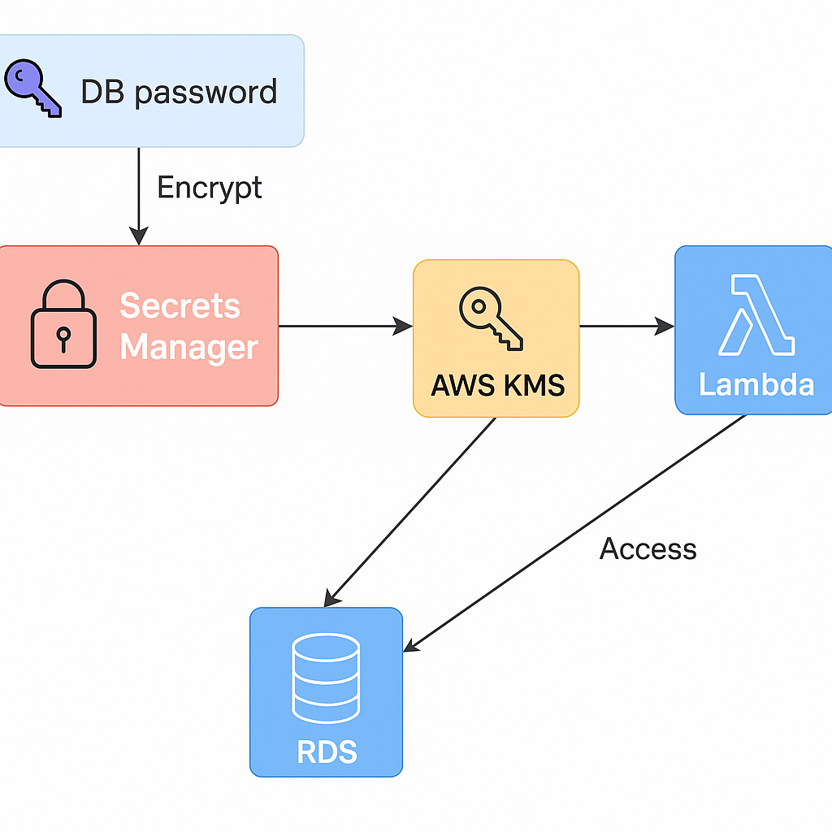
Patch Manager Systems Manager ka feature hai jo EC2 (ya on-premise servers) ko automatically update karta hai with latest security patches.
CMK ka full form hota hai Customer Master Key — ye aapka encryption ka base key hota hai jo KMS manage karta hai.

